Appendix 2. Plant architecture and fruit setting patterns for USDA 846-1 (P₁) and “Top-Mark” (P₂) (spacing at 0.70 m within rows on 2 m centers, 36,300 plants/ha) grown at Arlington (AR) and Hancock (HCK) Wisconsin in 2001.

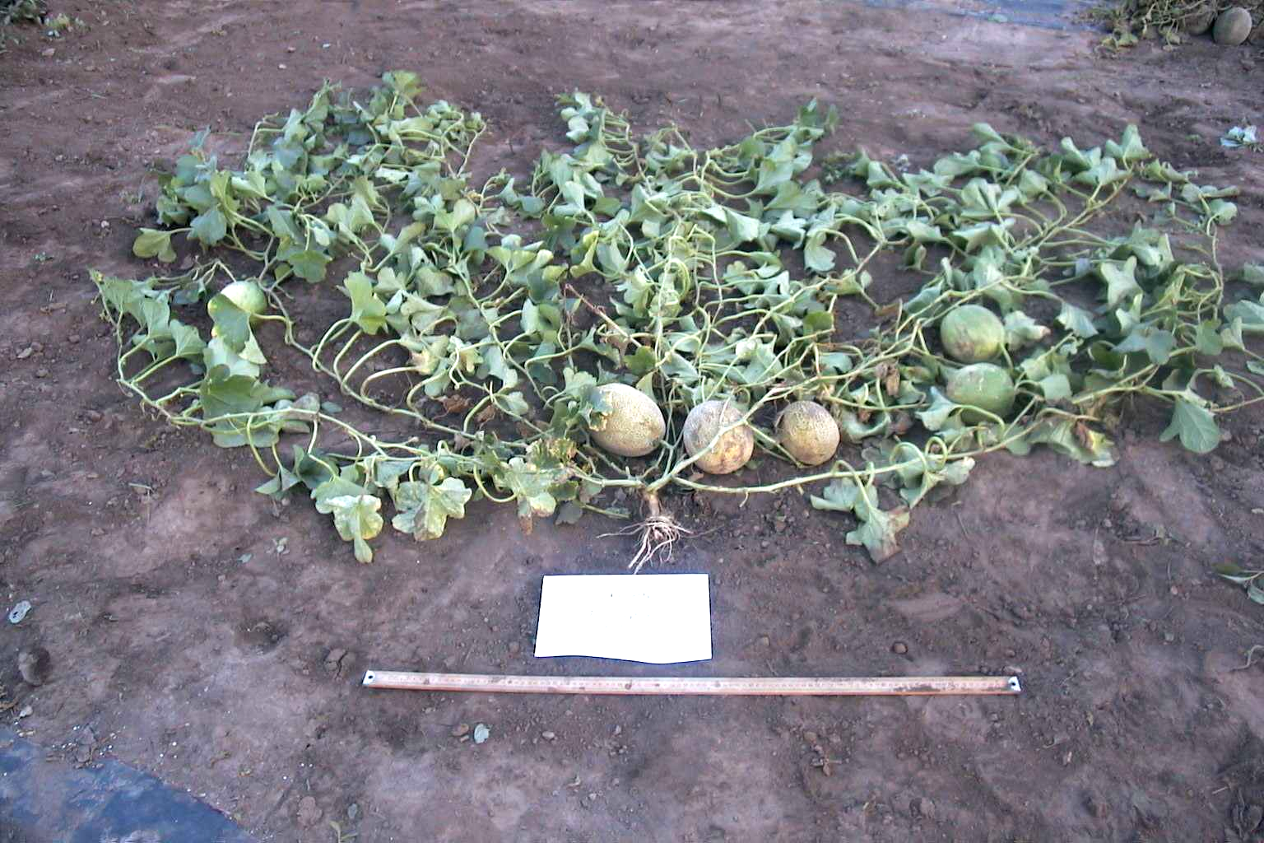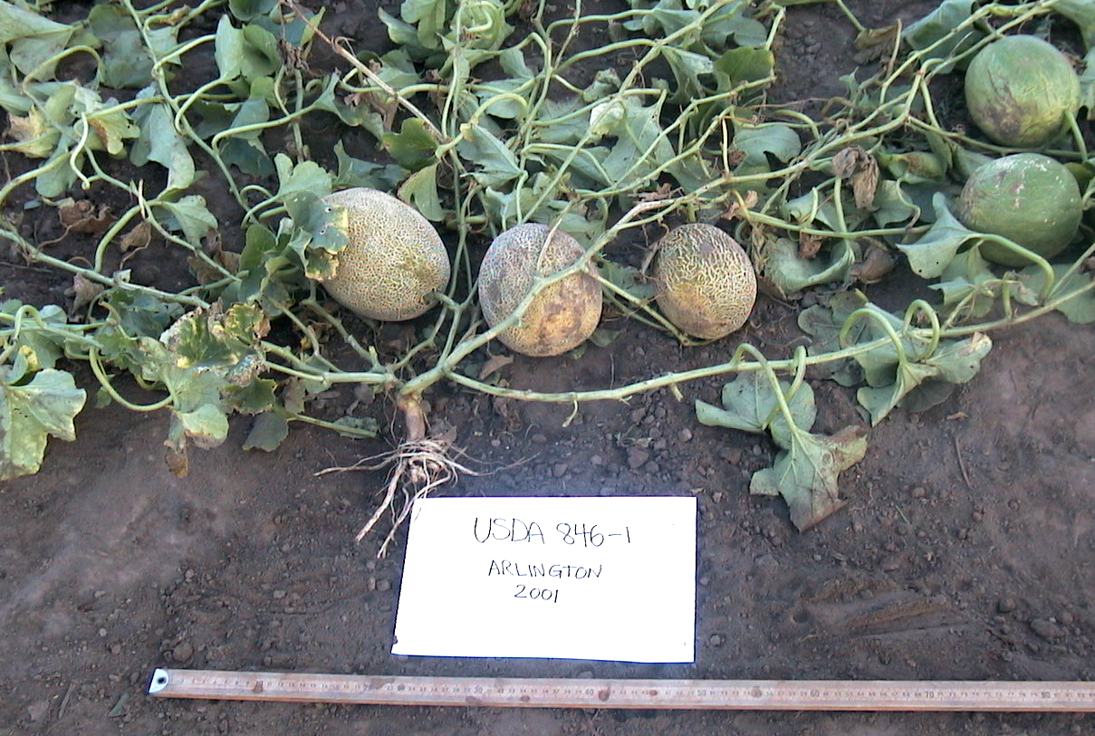
P₁ AR
P₂ AR

P₂ AR
P₂ AR
P₁ HCK
P2 AR
P₁ HCK
P₁ AR
P₂ HCK
P₂ HCK

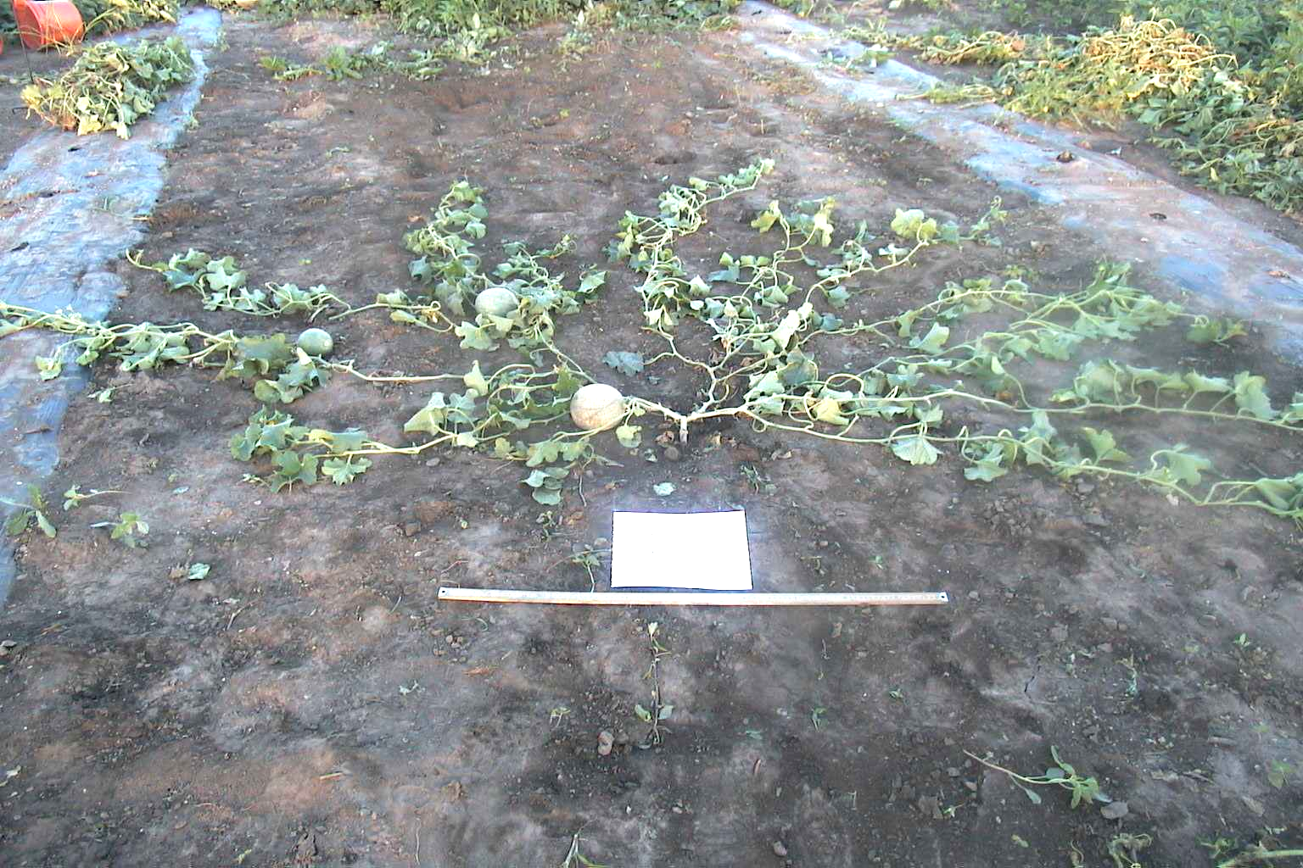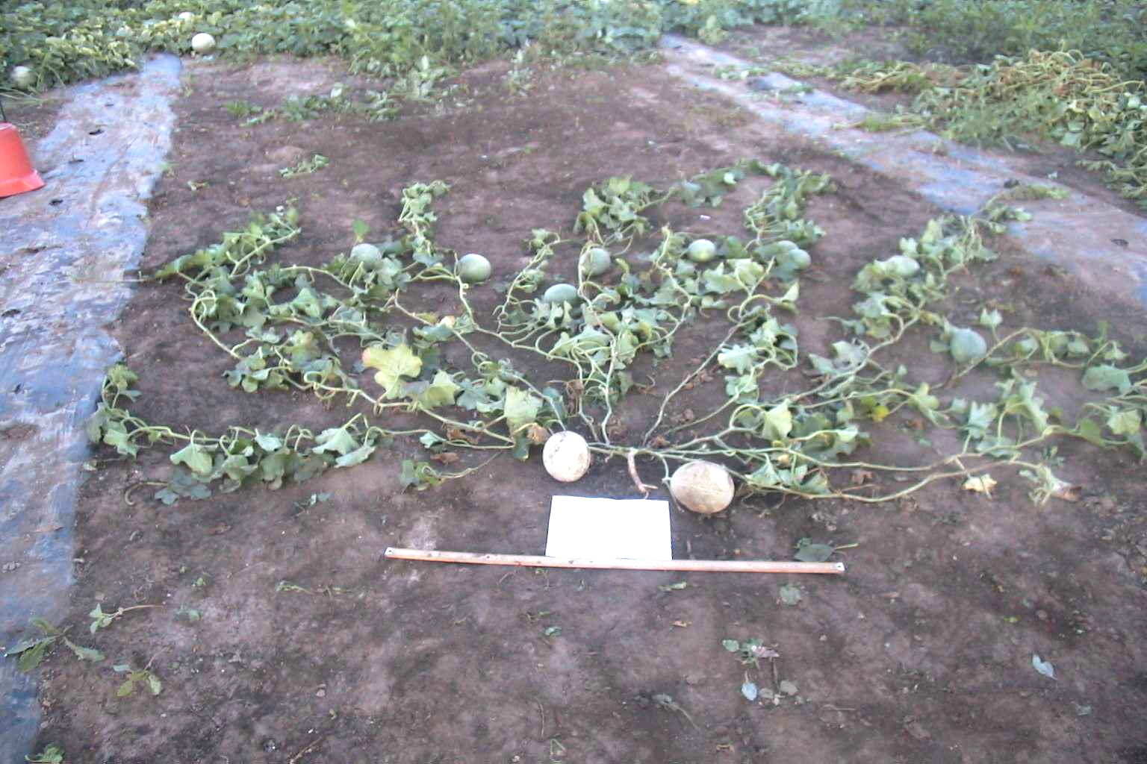

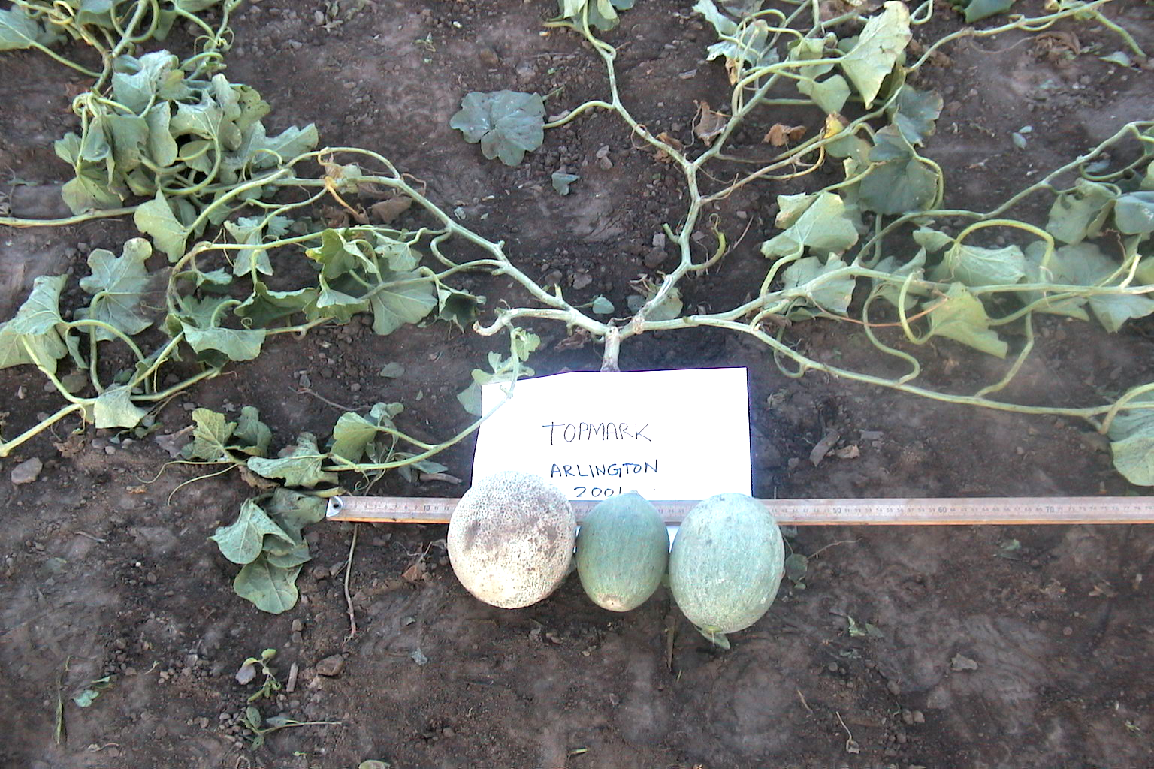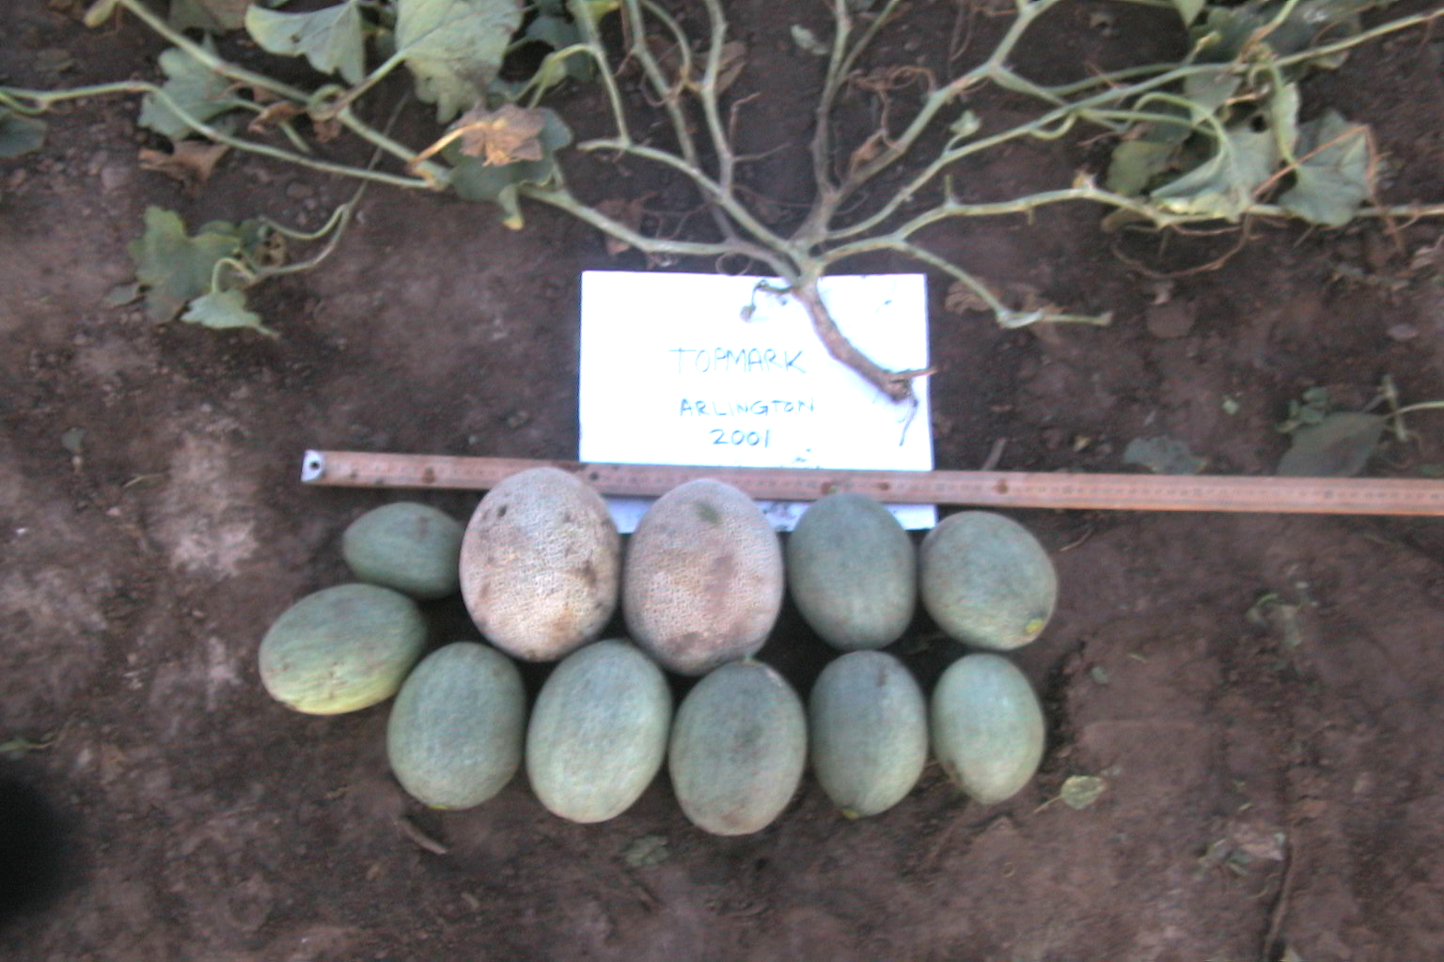

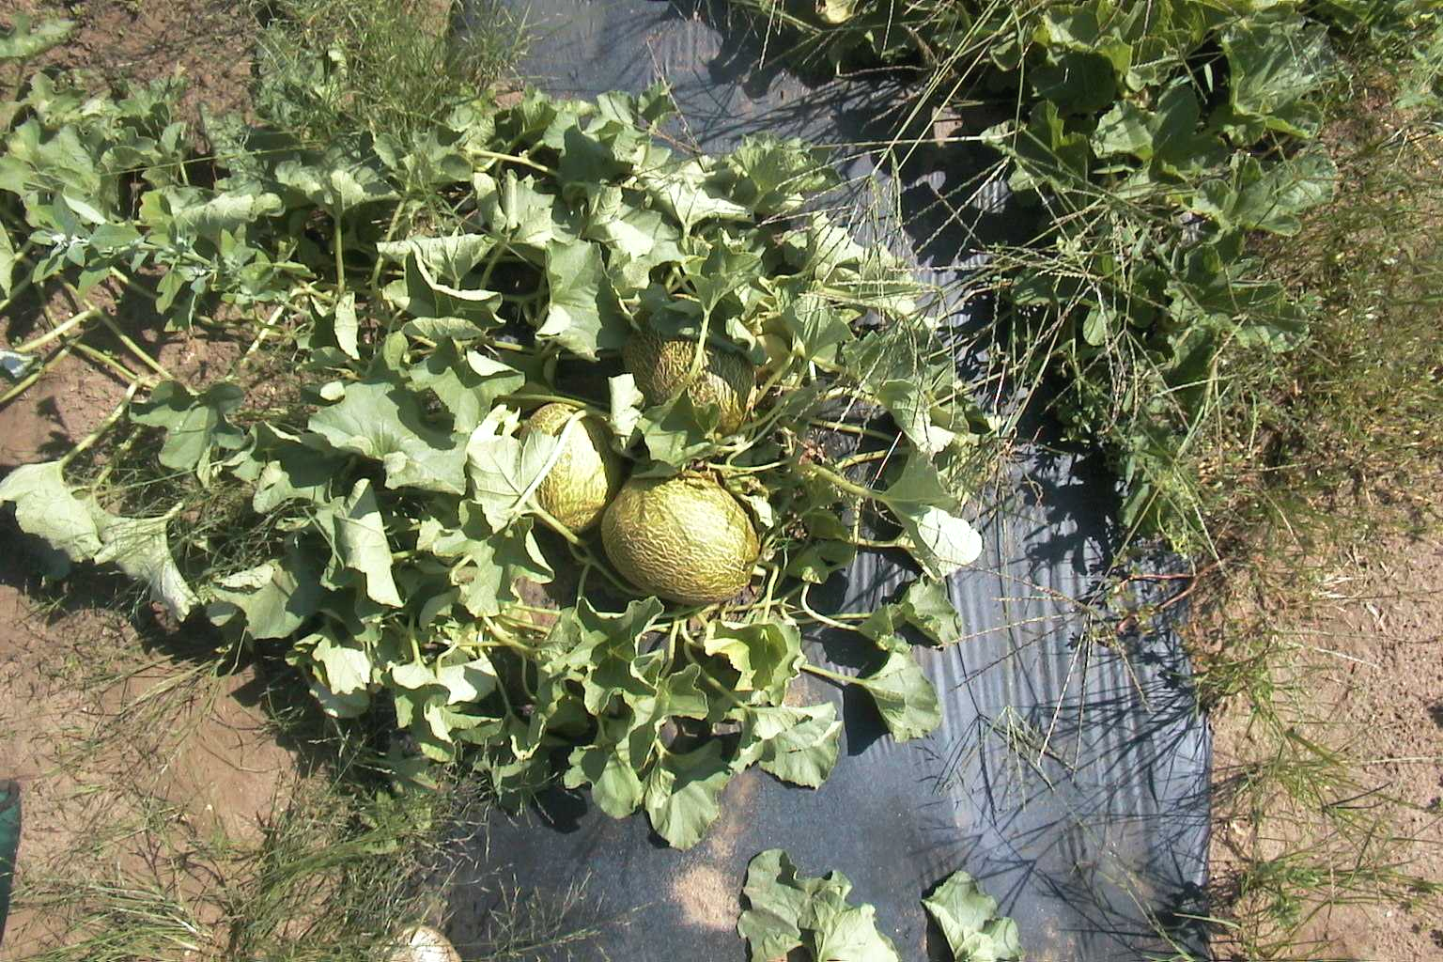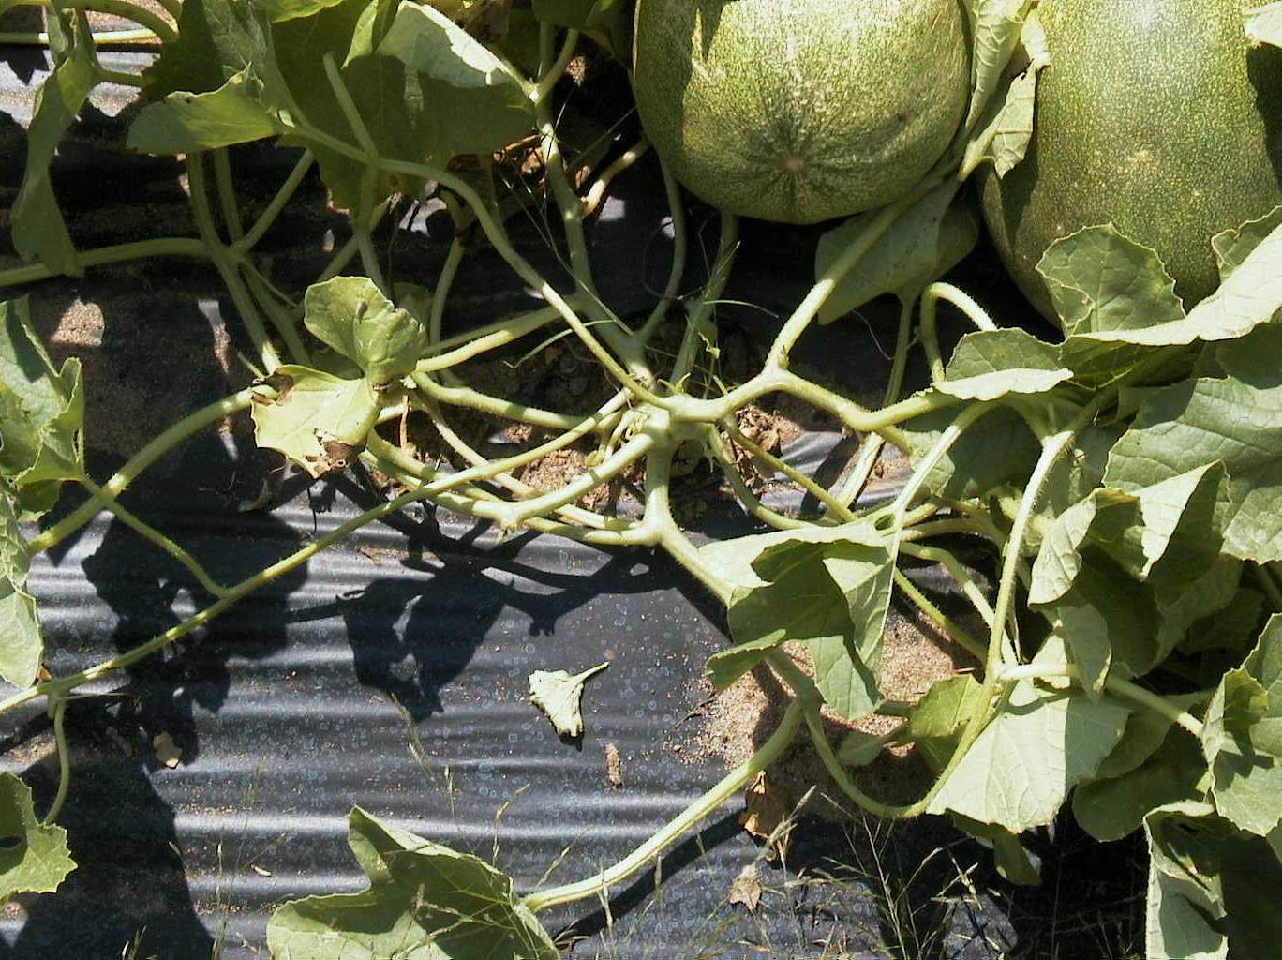
Brdnest


